ANAND SUMMER SCHOOL
Course Name: “Save Your Environment”
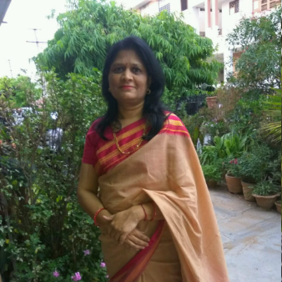
Mentor:
Prof. Sanjana Chugh Ph.D (Chemistry)
Prof. Susmita Sharma Ph.D (Chemistry)
20+ Yrs. Experience in Academia & Research
Objective & Details: Awareness about Environment, to serve as an environmental resource, through service, to know interconnectedness with environments. Use of techniques to save environment. Understanding Eco-friendly techniques.
Outcomes of the Courses: Students will be able Know how to protect environment, demonstrate an integrative approach to environmental issues with a focus on sustainability, Understand and evaluate the global scale of environmental problems and their solutions.
Weekly Activities:
Week 1
Basics about Environment and Environmental issues, Impact of Environmental problems on our Earth through Clips videos and activities
Week 2
Solution of various Environmental problems by knowing solid waste management (Recycle, Reuse etc.), Waste to Energy, Water management, Green technologies through Videos, Clips and activities ( Best out of waste, Quiz, Poster making competition etc.)

